52nd Annual
2026 South Dakota Pork Chop Open
Friday, August 7, 2026
Sponsor Benefits

Platinum (Minimum $600), Gold ($400), and Silver ($250) Sponsorship Benefits:

- A 1 ½ by 2-foot sign at the tee box for Platinum & Gold and around the putting green for Silver.
- Your company name listed on the scorecard as a sponsor. (logo for Platinum level sponsors)
- Network with over 175 industry individuals.
- Meet the pork producers at your sponsored tee (Platinum & Gold).
- Pass out promotional items at the tee (Platinum & Gold).
- Design a fun game at your hole (Platinum & Gold).

We have 4 $1,000.00 hole-in-one prizes.

- Sponsorships for these holes are sold in $500 increments.
- Sponsors will have their company recognized at the hole with a sign.
- Your company name on the scorecard.
- Meet the pork producers at your Hole-in-One sponsorship.
- Pass out promotional items at the hole.

Other sponsorships available, but not limited to:

- Putting Contest
- Driving Range
- Meals
- Hole Prizes

Send payment
Names, Addresses & Phone Numbers: Questions:

Ashley Gelderman OR Keith Matthiesen
SD Master Pork Producers SD Master Pork Producers
2220 E. 54th Street N
Sioux Falls, SD 57104
Phone: 605-335-9693 ext. 3 Phone: 605-310-5084
Cell: 605-530-3071 keithmatthiesen511@gmail.com
AGelderman@standardnutrition.com

Become a member of the SD Master Pork Producers and get involved!
The SD Master Pork Producers Association is made up of Allied Industry Individuals whose goal is to recognize outstanding South Dakota Pork Producers and to promote the South Dakota Swine Industry in a positive manner.
SD Master Pork Producers have been very active for over 50 years in promoting the swine industry and plan to continue that tradition for many years to come. Annually, we select and recognize outstanding SD Master Pork Producer winners, who are recognized at the SD Master Pork Producer Banquet during the SDPPC Pork Congress. The MPPA Banquet, along with our Annual Pork Chop Open, has helped us raise over $100,000 in funds that support scholarships at SDSU for students interested in swine production. We have also been able to donate thousands of pounds of pork to The Banquet, an organization that provides meals for the less fortunate, and pork certificates to the families of deployed military personnel during the holidays.
Here is how you or your organization can become a member of the SD Master Pork Producers Association:
Platinum Sponsorship: Sponsorship level minimum of $600. Membership to the MPPA, sponsorship of the Pork Chop Open, and 1 team for the 4-person Scramble, plus additional contributions such as Hole-in-One sponsor or Lunch sponsor.
Gold Sponsorship: $400. Membership to the MPPA, sponsorship of the Pork Chop Open, and 1 team for the 4-person Scramble.
Silver Sponsorship: $250. Membership to the MPPA, sponsorship of the Pork Chop Open.

For membership, please fill out below and return with a check for the appropriate amount to Ashley Gelderman at
Standard Nutrition - 2220 E. 54th Street N. Sioux Falls, SD 57104.

Company Name:_____________________________________________Contact:_______________________________
Mailing Address: __________________________________________________________________________________
Email Address: ____________________________________________Phone Number:__________________________

Platinum Sponsorship $600.00 minimum
(Included) Gold Membership $400.00
Hole In One Sponsor $500.00
Lunch Sponsor $200.00
Other – Please Specify

Gold Sponsorship $400.00

Strings (1 per person) - $20.00 per team $

Mulligan’s (1 per person) - $20.00 per team option only $

We want to be a SILVER SPONSOR
(Membership to the MPPA, Pork Chop Open Sponsor) $250.00

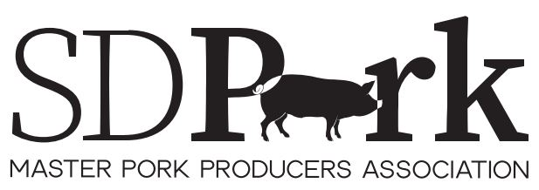

( ) Yes, I need to have a receipt sent.
( ) This letter will be a receipt of my payment.

