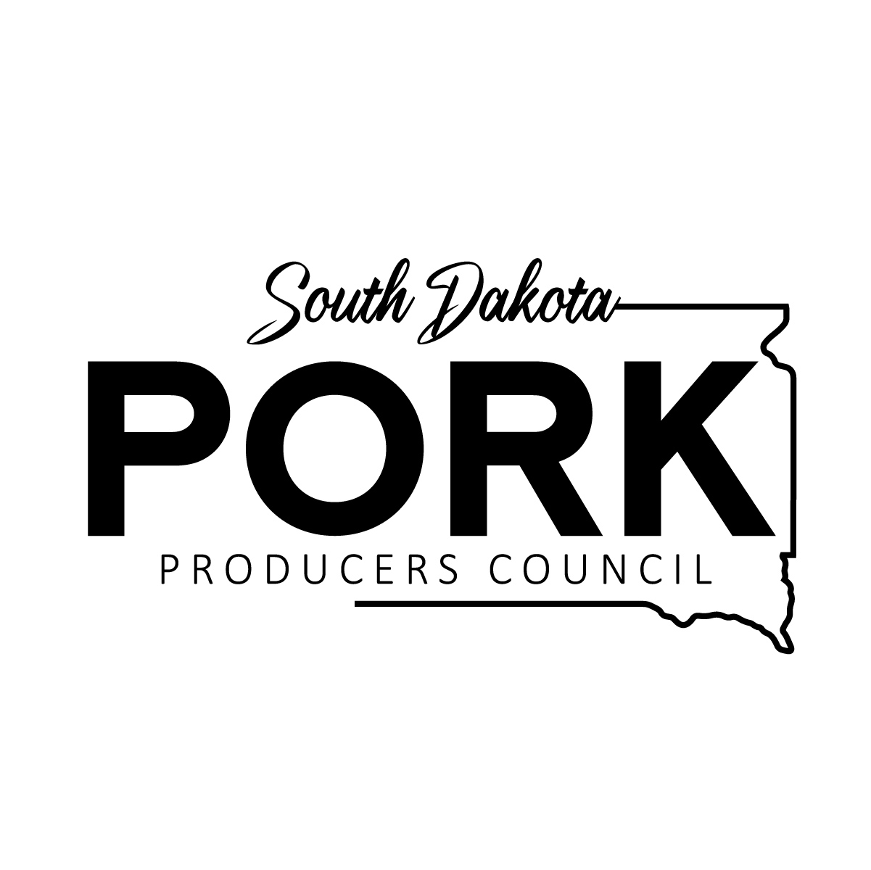

South Dakota Pork Producers Council
2027 Ambassador Program Application

General Information:

First Name:_________________________ M.I.:_________ Last Name:_________________________
Age:__________ Date of Birth:_______________________ Shirt Size: _________________________
Street Adress:________________________________________________________________________
City:__________________________________ State:______________ Zip:______________________
Cell Phone:____________________________ Parent Cell #:_____________________________
E-mail Address:______________________________________________________________________
Parent/Guardian:___________________________ Relationship:_______________________________
Street Address:_______________________________________________________________________
City:_________________________________________ State:______________ Zip:_______________
High School Seniors:
Intended Post Secondary School:_________________________________________________________
Intended Major: ______________________________________________________________________
College Students:
Name of School:______________________________________________________________________
Current Major:_______________________________________________________________________
Academic Advisor: ___________________________________________________________________
Expected Date of Degree Completion:_____________________________________________________

Short Answer:
What do you hope to gain from being the South Dakota Pork Producers Council Pork Ambassador?

Include: application, resume, 3 letters of recommendation, and a current transcript
I certify that the information given on this application is correct and I agree that if accepted, I shall abide by all standards and regulations as specified by the South Dakota Pork Producers Council.

Signature:______________________________________________ Date:________________________

Please submit application, resume, three letters of recommendation* and a current transcript to:
South Dakota Pork Producers Council
Abbey Riemenschneider
4615 West Homefield Drive
Sioux Falls, SD 57106

Deadline: October 1, 2026

Selected students will be notified to schedule an interview.
*Letters of Recommendation can be sent directly from references to Abbey via mail or email!
abbeyr@sdppc.org

