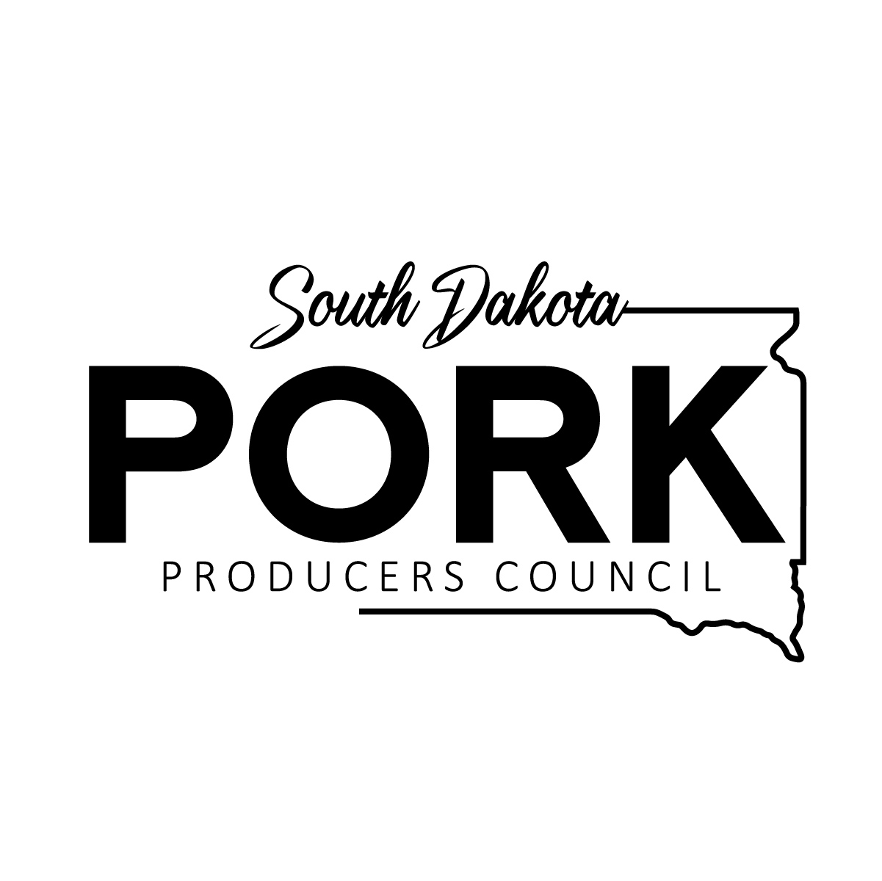

South Dakota Pork Producers Council
Pork Ambassador Program

Description:

The South Dakota Pork Ambassador Program is designed to provide an opportunity to become actively involved in the South Dakota pork industry. The program helps develop strong relationships with both pork producers and allied industry members. It is an opportunity to learn about pork production, the industry, and to improve communication and leadership skills. The main goal of the Pork Ambassador Program is to promote the South Dakota Pork Producers Council and the swine industry at various events. The successful candidate will gain valuable experience and develop relationships that will last a lifetime.

Rules:

- The applicant must be a minimum of a senior in high school as of January 1st of the year they will begin the program and must continue enrollment at a technical school, community college, or 4-year university during their term as Pork Ambassador.

- Applicants may apply more than once but may only be selected as an ambassador once.

- Applicant must be a resident of South Dakota.

- Applicant must have their own transportation and a valid driver’s license.

Judging and Selection:

Judging and selection will take place in two rounds.
Round One consists of an application, resume, three letters of recommendation, and a current transcript. Applications are due by October 1, 2026.
Round Two consists of a personal interview. Applicants that are chosen to move on to round two selections will be notified by October 8, 2026. Applicants should be prepared to discuss and demonstrate their knowledge of the pork industry and organizational issues during the interview process. All applicants will be notified of standing by November 1, 2026, and selected individual(s) will be officially announced at the South Dakota Pork Congress and Trade Show on January 13, 2027. The Ambassador(s) will report to the South Dakota Pork Producers Council Director of Programs and Communications.

Duties:

The Ambassador(s) will begin the program at the 2027 South Dakota Pork Congress and Trade Show and finish the program at the 2028 South Dakota Pork Congress and Trade Show.

The Ambassador(s) is required to attend 6 events throughout the year.
The required events are:
- South Dakota Pork Congress and Trade Show 2027
- Ambassador Training
- World Pork Expo OR MN Young Leaders in Ag Conference
- One Executive Board Meeting (at minimum)
- 1 Day at the South Dakota State Fair Food and/or Info Booth
- South Dakota Pork Congress and Trade Show 2028

The Ambassador will select at least 3 other events to attend:
- Promotional events (Expo For Her, grocery store promotions, etc)
- County Fair Information Booth (Turner, Brown, and Sioux Empire)
- Pig Pals @ Sioux Empire Fair
- Swine Summit @ SDSU with Director of Membership, Outreach, and Engagement

If the Ambassador(s) would like to substitute one of these events with another, they can do so with the approval of the Director of Programs and Communications.

The Ambassador(s) will receive two South Dakota Pork Producers Council shirts and will be awarded a $2,500 scholarship at the conclusion of the program. The Ambassador(s) will be reimbursed for lodging and travel expenses in accordance with the SDPPC policy.

